

**FACULTY OF COMPUTER SYSTEMS & SOFTWARE ENGINEERING**

**MidTerm**

**COURSE : SOFTWARE Testing & Maintenance**

**COURSE CODE : BCS3323**

**LECTURER : DR ABDULRAHMAN A. ALSEWARI**

**DATE : 19 Oct. 2016**

**DURATION : 90 minutes**

**SEMESTER : SESSION 2016/2015 SEMESTER II**

**Student Name :**

**Student ID :**

**INSTRUCTIONS TO CANDIDATES**

1. There are ***FOUR (4)*** questions. Answer **ALL** questions.
2. Write your answer in the answers booklet provided.
3. Answer EACH question on a new page.

**EXAMINATION REQUIREMENTS:**

NONE

**DO NOT TURN THIS PAGE UNTIL YOU ARE TOLD TO DO SO**

This examination paper consists of ***FIVE (5)*** printed pages including front page.

**ANSWER ALL QUESTIONS [60 MARKS]**

1. You executed your final 10 test cases to complete your test cycle. 4 test cases passed, 3 failed, 2 had exceptions and 1 is still in progress. What percent of execution should be indicated in your test progress report?
   1. 40%
   2. 70%
   3. **90%**
   4. 100%
2. How are exit criteria utilized?

To reprioritize remaining tasks

**To determine when to stop testing**

To indicate when additional test coverage can be achieved

To automatically determine the Go/No-Go decision

1. On the last project, insufficient resources were allocated for the configuration testing. When should this area be addressed for the next project?
2. **During planning**
3. During implementation
4. During execution
5. During closure
6. You have just finished the last cycle in system testing for a project. The exit criteria states that 90% of the test cases must pass. You have provided your manager with the following information:

Test cases passed: 70 Test cases failed: 5 Test cases passed with exception: 25

What problem is your manager likely to have with this information?

1. aA 90% pass rate was required so the project has not met the exit criteria
2. Only 5% of the test cases failed, so the 90% pass rate has been exceeded and people may think the product was tested too much
3. There is no risk rating associated with the test cases, so determining if 90% of the high risk test cases has passed is not possible
4. **The 25 test cases that “passed with exception” may contain problems that will affect the product in production so the 90% pass rate may not have been met**
5. You are testing software for an Automated Teller Machine (ATM) for a bank and you have noticed that anytime a withdrawal is made an email is sent to the card holder informing them that the withdrawal has been made. You have checked the requirements and this feature is not mentioned anywhere.

What should you do?

* 1. Nothing, this is probably an added feature that did not make it into the requirements
  2. Update the test case to include steps for verifying the email
  3. **Document the anomaly as this is an example of the software doing something it is not supposed to do**
  4. Make a note in the test case for future testers to check for the email generation

1. In the fundamental test process, when is test case priority / risk coverage assigned and when is that information used to determine execution sequence?
   1. Test Planning and Test Execution
   2. Test Analysis and Test Execution
   3. **Test Design and Test Implementation**
   4. Test Implementation and Test Execution
2. Which of the following would normally be delivered as part of the Test Closure activities?
   1. **Defect reports and known workarounds**
   2. Finalized requirements specifications
   3. Use cases and/or user stories depending on the SDLC
   4. Quality risk analysis
3. You are a Test Analyst for a company that provides incentives to its customers based on how much money they spend online shopping:

Category 1: $1 - $100 = 5%

Category 2: $100.01 - $500 = 7.5%

Category 3: Over $500 = 10%

The company recently discovered that their competitors were offering better incentives for the same amounts of money spent and now want to update their current incentive rate to match the competitor’s.

Using the equivalence partitioning test design technique, which of the following is the correct set of test cases to achieve 100% coverage with the minimum number of test cases?

* 1. $50, $150
  2. $0, $50, $150, $500
  3. $0, $1, $100, $500, $550
  4. **$0, $50, $150, $550, max amount + $50**

1. You are testing a login program that requires the password to be between 3 and 10 characters. Which of the following sets of test data would provide coverage for all the equivalence classes with the least number of tests?
   1. 333, 1234567890
   2. 22, AAA, 1234567890, 12345678901
   3. -1, 0, 55555, 123456789a!
   4. **1, 55555, 1234567890**
2. You are testing a login program that requires the password to be between 3 and 10 characters. Which of the following sets of test data would provide coverage for all the Boundary Values technique with the least number of tests?
   1. 333, 1234567890
   2. **22, AAA, 1234567890, 12345678901**
   3. -1, 0, 55555, 123456789a!
   4. 1, 55555, 1234567890
3. You are a Test Analyst for a company that provides incentives to its customers based on how much money they spend online shopping:

Category 1: $1 - $100 = 5%

Category 2: $100.01 - $500 = 7.5%

Category 3: Over $500 = 10%

The company recently discovered that their competitors were offering better incentives for the same amounts of money spent and now want to update their current incentive rate to match the competitor’s.

Using the two-value boundary value analysis test design technique, which of the following is the correct set of test cases to achieve 100% coverage with the minimum number of test cases?

$0, $1, $100, $500, max spend

$1, $100, $100.01, $500, $500.01, max spend, max spend+$0.01

$0, $1, $100, $150, $500, $550, max spend, max spend+$50

**$0, $0.99, $1, $100, $100.01, $500, $500.01, max spend, max spend+$0.01**

1. You are testing registration software that requires the user to create a password.

The following are the rules for the password

* Must be between 3 and 10 characters long
* Must contain at least two of the following character types:
  + Special character
  + Lower case alpha o Number
  + Upper case alpha
* If the password only contains two of the above, a weak symbol is displayed
* If the password only contains three of the above, a strong symbol is displayed
* If the password contains four of the above and is longer than 8 characters, a very strong symbol is displayed
* If the password contains four of the above but is 8 characters or less, a strong symbol is displayed

For these requirements, which of the following is the correct list of Conditions for a decision table?

**D** IS THE CORRECT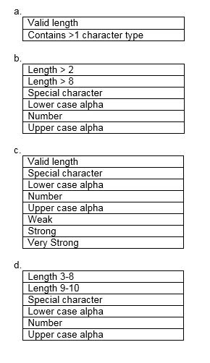

1. You are currently working with a web-based retail company that recently created an online shopping portal. The user is only allowed to use one form of payment, credit card or debit card (with PIN). The system interfaces with the warehouse software system to verify items are in stock prior to confirming the order. In addition, a third party credit/debit card vendor validates the credit/debit card and confirms available funds to cover the transaction prior to the final sale. Given this information, using the decision table technique, what is the minimum number of test cases you would need to test the full decision table and what is the minimum number of test cases you would need to test the collapsed decision table?

8, 4

12, 6

**16, 6**

32, 16

1. You are testing login software. If the user enters a valid username/password combination, they are taken to the welcome page. If they enter an invalid combination, they are taken to the Forgot password page where they can then request to be emailed their username or password. Which of the following state tables correctly shows the state changes from the Login state?

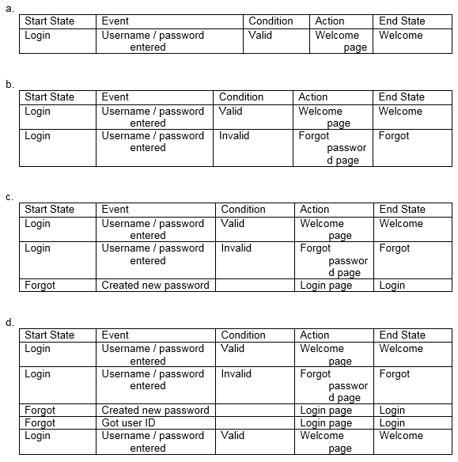

**B** is correct

1. You have recently worked on a project that launched a new web site. The usage of the web site is lower than expected in the first three months since it was deployed. You are concerned that there may be usability issues. You have checked the abandonment rate and it doesn’t appear to be higher than comparable sites. What should you do to get more information regarding possible usability issues on this product?

Conduct a formative analysis

Conduct a usability lab and observe potential users to identify any learnability issues

Conduct an accessibility scan to determine if there are accessibility issues

**Conduct a survey of the users to see what they like/dislike about the site**

1. You are testing registration software that requires the user to create a password. The following are the rules for the password

* Must be between 3 and 10 characters long
* Must contain at least two of the following character types: o Special character
  + Lower case alpha
  + Number
  + Upper case alpha
* If the password only contains two of the above, a weak symbol is displayed
* If the password only contains three of the above, a strong symbol is displayed
* If the password contains four of the above and is longer than 8 characters, a very strong symbol is displayed
* If the password contains four of the above but is 8 characters or less, a strong symbol is displayed

For these requirements, which of the following is the correct list of Results for a decision table?

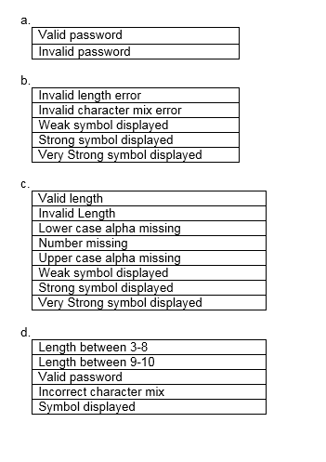

**B IS CORRECT**

1. Which of the following statements BEST describes one of the seven key principles of software testing?

a) Automated tests are better than manual tests for avoiding the Exhaustive Testing.

b) Exhaustive testing is, with sufficient effort and tool support, feasible for all software.

**c) It is normally impossible to test all input / output combinations for a software system.**

d) The purpose of testing is to demonstrate the absence of defects.

1. Which of the following statements BEST describes the difference between testing and debugging?

a) Testing pinpoints (identifies the source of) the defects. Debugging analyzes the faults and proposes prevention activities.

**b) Dynamic testing shows failures caused by defects. Debugging finds, analyzes, and removes the causes of failures in the software.**

c) Testing removes faults. Debugging identifies the causes of failures.

d) Dynamic testing prevents causes of failures.Debugging removes the failures.

1. Which of the following statements are TRUE?

A. Regression testing and acceptance testing are the same.

B. Regression tests show if all defects have been resolved.

C. Regression tests are typically well-suited for test automation.

D. Regression tests are performed to find out if code changes have introduced or uncovered defects.

E. Regression tests should be performed in integration testing.

a) A, C and D and E are true; B is false.

b) A, C and E are true; B and D are false.

**c) C and D are true; A, B and E are false.**

d) B and E are true; A, C and D are false.

1. Which of the following statements are true for the equivalence partitioning test technique?

A. Divides possible inputs into classes that have the same behaviour.

B. Uses both valid and invalid partitions.

C. Makes use only of valid partitions.

D. Must include at least two values from every equivalence partition.

E. Can be used only for testing equivalence partitions inputs from a Graphical User Interface.

a) A, B and E are true; C and D are false.

b) A, C and D are true; B and E are false.

c) A and E are true; B, C and D are false.

**d) A and B are true; C, D and E are false.**

|  |  |  |  |
| --- | --- | --- | --- |
| Student Name:  Student ID: | | | |
| Question No | Answer | Question No | Answer |
| 1 | C | 11 | D |
| 2 | B | 12 | D |
| 3 | A | 13 | C |
| 4 | d | 14 | B |
| 5 | c | 15 | D |
| 6 | C | 16 | B |
| 7 | A | 17 | C |
| 8 | D | 18 | B |
| 9 | D | 19 | C |
| 10 | B | 20 | D |